**Topics: Descriptive Statistics and Probability**

1. Look at the data given below. Plot the data, find the outliers and find out $μ, σ, σ^{2}$

|  |  |
| --- | --- |
| **Name of company** | **Measure X** |
| Allied Signal | 24.23% |
| Bankers Trust | 25.53% |
| General Mills | 25.41% |
| ITT Industries | 24.14% |
| J.P.Morgan & Co. | 29.62% |
| Lehman Brothers | 28.25% |
| Marriott | 25.81% |
| MCI | 24.39% |
| Merrill Lynch | 40.26% |
| Microsoft | 32.95% |
| Morgan Stanley | 91.36% |
| Sun Microsystems | 25.99% |
| Travelers | 39.42% |
| US Airways | 26.71% |
| Warner-Lambert | 35.00% |

**SOL.** The mean is found to be 0.332713

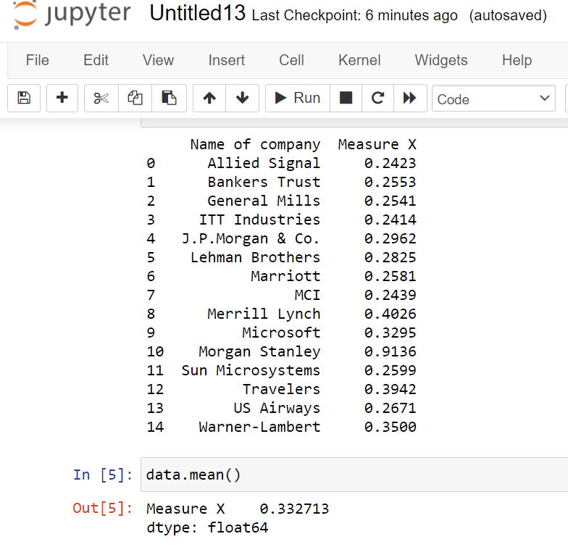



Answer the following three questions based on the box-plot above.

1. What is inter-quartile range of this dataset? (please approximate the numbers) In one line, explain what this value implies. **SOL. IQR=(12.5-5)=7.5**
2. What can we say about the skewness of this dataset? **SOL.** It is positively skewed to the right.
3. If it was found that the data point with the value 25 is actually 2.5, how would the new box-plot be affected? **SOL. IQR=(1.25-0.5)=0.75** This shows that there is very less spread in the data.

3.



Answer the following three questions based on the histogram above.

1. Where would the mode of this dataset lie

**SOL.** The mode should lie between 95 to 105

1. Comment on the skewness of the dataset. **SOL.** Skewed to the right.
2. Suppose that the above histogram and the box-plot in question 2 are plotted for the same dataset. Explain how these graphs complement each other in providing information about any dataset.

**SOL.** Both the boxplot and the above histogram tell us the dataset is skewed to the right

1. AT&T was running commercials in 1990 aimed at luring back customers who had switched to one of the other long-distance phone service providers. One such commercial shows a businessman trying to reach Phoenix and mistakenly getting Fiji, where a half-naked native on a beach responds incomprehensibly in Polynesian. When asked about this advertisement, AT&T admitted that the portrayed incident did not actually take place but added that this was an enactment of something that “could happen.” Suppose that one in 200 long-distance telephone calls is misdirected. What is the probability that at least one in five attempted telephone calls reaches the wrong number? (Assume independence of attempts.)

**SOL.** 1 is misdirected in 200 calls, so probability of correct calls=199//200;

We have n=5;

Prob(atleast 1 wrong)=1-prob(all right)=1-(199/200)^5=**0.025**

1. Returns on a certain business venture, to the nearest $1,000, are known to follow the following probability distribution

|  |  |
| --- | --- |
| x | P(x) |
| -2,000 | 0.1 |
| -1,000 | 0.1 |
| 0 | 0.2 |
| 1000 | 0.2 |
| 2000 | 0.3 |
| 3000 | 0.1 |

1. What is the most likely monetary outcome of the business venture?

**SOL.**

|  |  |  |
| --- | --- | --- |
| x | P(x) | (x*p(x)) |
| -2,000 | 0.1 | -200 |
| -1,000 | 0.1 | -100 |
| 0 | 0.2 | 0 |
| 1000 | 0.2 | 200 |
| 2000 | 0.3 | 600 |
| 3000 | 0.1 | 300 |
|  | Sum | 800 |

Since 800 is most close to 1000. So, 1000 is the most likely monetary outcome.

1. Is the venture likely to be successful? Explain

**SOL.** Yes, Since the expected value is +800

1. What is the long-term average earning of business ventures of this kind? Explain

**SOL.** The long term expected earning is 800

1. What is the good measure of the risk involved in a venture of this kind? Compute this measure

**SOL. Risk=Loss*probability**=(-2000*0.1)+(-1000*0.1)=**-300**